Restaurant Recommendation System Using Machine Learning

Machine Learning Internship Project Report

Submitted to: Cognifyz Technologies

Submitted By: Dixa

Course: B.Tech Computer Science Engineering (AI & ML)

Date: 6 July, 2026

1. Introduction
With thousands of restaurants available across different cities, selecting a restaurant that matches a user's preferences can be challenging. Recommendation systems help users discover restaurants that best suit their interests by analyzing available restaurant information and identifying similar options.
This project develops a Content-Based Restaurant Recommendation System using machine learning techniques. The system recommends restaurants based on features such as cuisine, city, and price range. It applies text vectorization and similarity measurement to identify restaurants with similar characteristics and provide personalized recommendations.

2. Objective
The objectives of this project are:
- Develop a content-based restaurant recommendation system.
- Perform data preprocessing and cleaning.
- Explore and analyze restaurant data through visualization.
- Generate recommendations using restaurant features.
- Measure similarity between restaurants using machine learning techniques.
- Provide accurate and relevant restaurant suggestions based on user preferences.

3. Dataset Description
Dataset Information
Attribute | Value
Dataset Name | Zomato Restaurant Dataset
Total Records | 9551
Total Features | 21
Recommendation Type | Content-Based Filtering
Important Features Used
- Restaurant Name
- City
- Cuisines
- Average Cost for Two
- Price Range
- Aggregate Rating
- Votes
- Has Online Delivery
- Has Table Booking
The dataset contains restaurant information collected from multiple cities and includes details related to cuisine, pricing, customer ratings, and restaurant services.

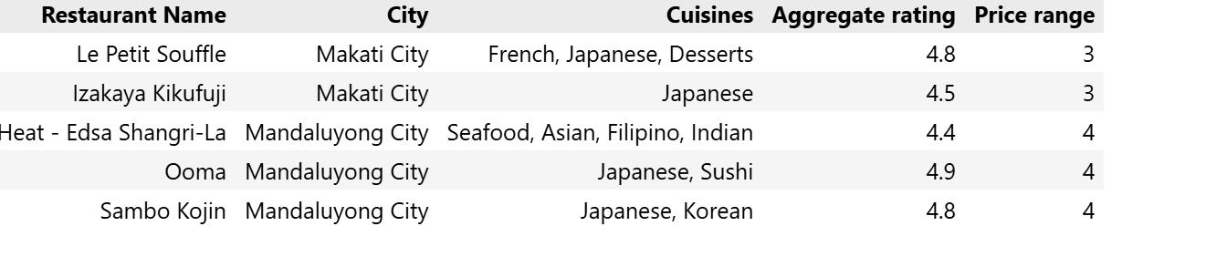
4. Data Preprocessing
The following preprocessing steps were performed before building the recommendation system:
- Loaded the dataset using Pandas.
- Checked for missing values.
- Replaced missing values in the Cuisines column with "Unknown".
- Removed duplicate records, if any.
- Selected relevant features for recommendation.
- Combined selected features into a single text feature.
- Converted text data into numerical vectors using CountVectorizer.
These preprocessing steps prepared the dataset for similarity analysis.

5. Exploratory Data Analysis (EDA)
Several visualizations were created to better understand the dataset.
Visualizations Included
- Rating Distribution
- Top Cities by Number of Restaurants
- Most Popular Cuisines
- Price Range Distribution
- Votes vs Aggregate Rating
- Correlation Heatmap
Observations
- Most restaurants have ratings between 3.5 and 4.5.
- North Indian and Chinese cuisines are the most common.
- Restaurants with more customer votes generally have higher ratings.
- Medium-priced restaurants appear more frequently in the dataset.
- Online delivery is available for many highly rated restaurants.
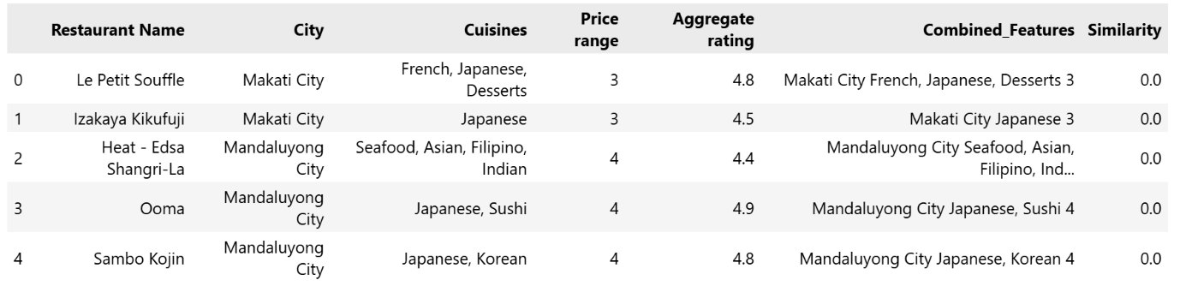

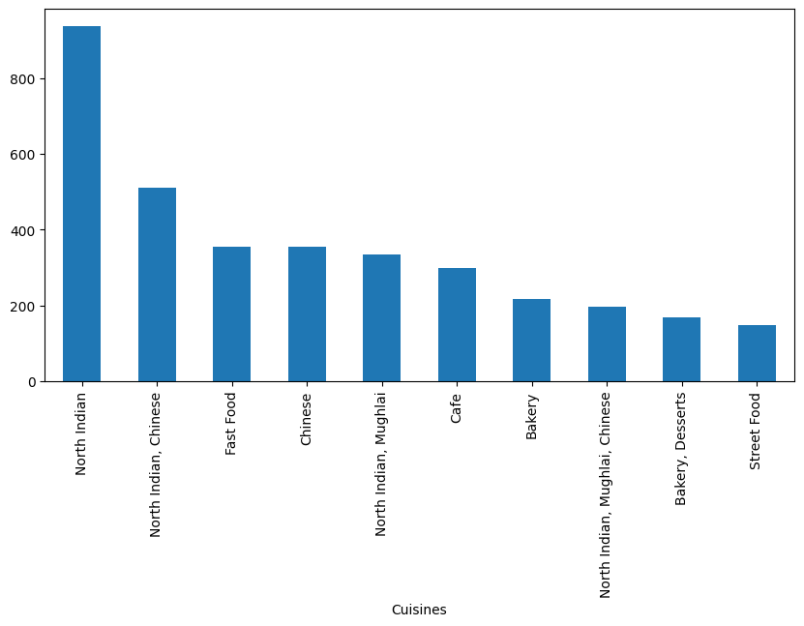
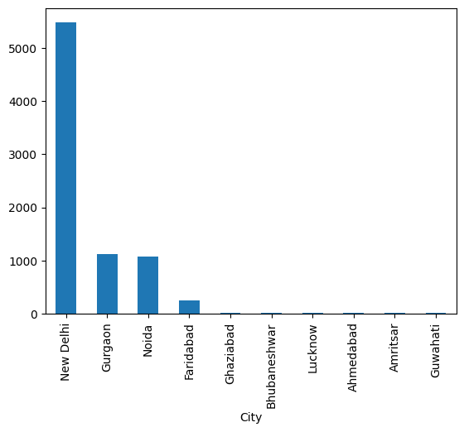
6. Content-Based Recommendation System
This project implements a Content-Based Filtering recommendation approach.
Methodology
- Selected important restaurant features.
- Combined the selected features into a single text representation.
- Converted text into numerical vectors using CountVectorizer.
- Calculated similarity scores using Cosine Similarity.
- Recommended restaurants with the highest similarity scores.

Workflow
Restaurant Dataset
↓
Data Cleaning
↓
Feature Selection
↓
Combined Features
↓
CountVectorizer
↓
Cosine Similarity
↓
Top Restaurant Recommendations

7. Recommendation Results
The recommendation system successfully suggests restaurants with similar characteristics.
Example User Preference
Feature | Value
City | New Delhi
Cuisine | North Indian
Price Range | 3
Sample Recommendations
- Kopper Kadai
- Zabardast Indian Kitchen
- Band Baaja Baaraat
- Pind Balluchi
- The GT Road
The recommended restaurants closely matched the selected cuisine, city, and pricing preferences.
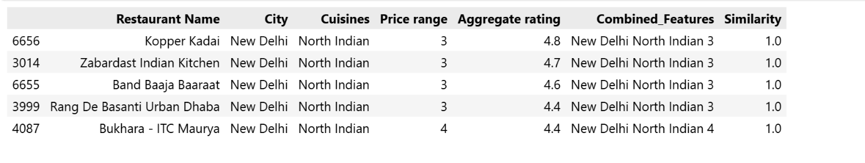

8. Evaluation
The recommendation system was evaluated by testing different combinations of user preferences.
Evaluation Criteria
- Similarity of recommended restaurants
- Relevance to selected cuisine
- Matching city preferences
- Price range consistency
Findings
- Recommendations were highly relevant for common cuisines.
- Restaurants recommended belonged to similar categories and locations.
- Content-Based Filtering effectively identified restaurants with comparable characteristics.
- The system generated meaningful recommendations for different user preferences.

9. Conclusion
This project successfully developed a Content-Based Restaurant Recommendation System using machine learning techniques. By applying CountVectorizer and Cosine Similarity, the system generated personalized restaurant recommendations based on cuisine, city, and price range.
The recommendation engine demonstrated the effectiveness of content-based filtering in identifying restaurants with similar characteristics and can serve as a foundation for more advanced recommendation systems.

10. Future Scope
The recommendation system can be enhanced through the following improvements:
- Hybrid Recommendation System
- Collaborative Filtering
- TF-IDF Vectorization
- Deep Learning-Based Recommendation Models
- Personalized User Profiles
- Real-Time Restaurant Recommendation
- Streamlit Web Application Deployment
- Integration with Restaurant APIs

11. References
- Cognifyz Technologies – Machine Learning Internship Guidelines.
- Scikit-learn Documentation – CountVectorizer and Cosine Similarity.

